OVER 16’S ONLY (PLEASE CIRCLE YOUR ANSWERS)

Name……………………………….. Date of Birth………………………

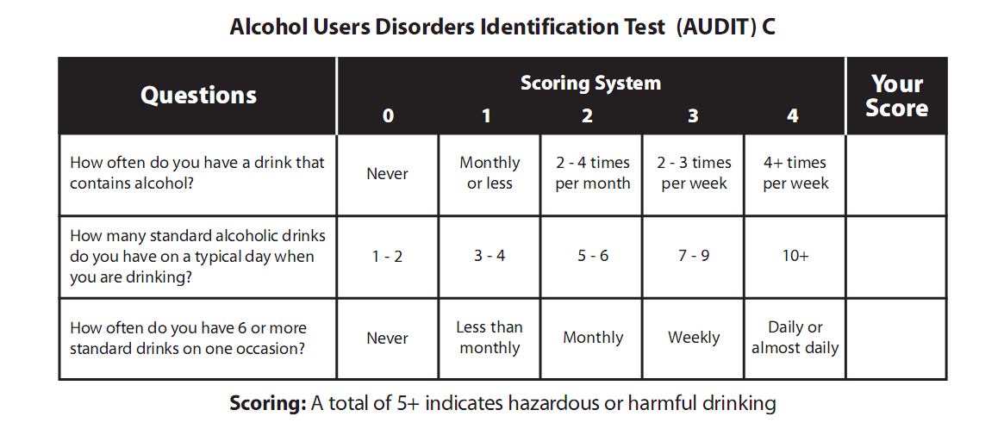
IF YOUR SCORE IS 5 AND OVER WE CAN OFFER YOU AN APPOINTMENT WITH THE DOCTOR WOULD YOU LIKE AN APPOINTMENT? YES □ NO □

OVER 16’S ONLY (PLEASE CIRCLE YOUR ANSWERS)

Name……………………………….. Date of Birth………………………

IF YOUR SCORE IS 5 AND OVER WE CAN OFFER YOU AN APPOINTMENT WITH THE DOCTOR
WOULD YOU LIKE AN APPOINTMENT? YES □ NO □

